Supportive Care Team
This team incorporates Specialist Palliative Care, Acute Oncology and Cancer Unknown Primary
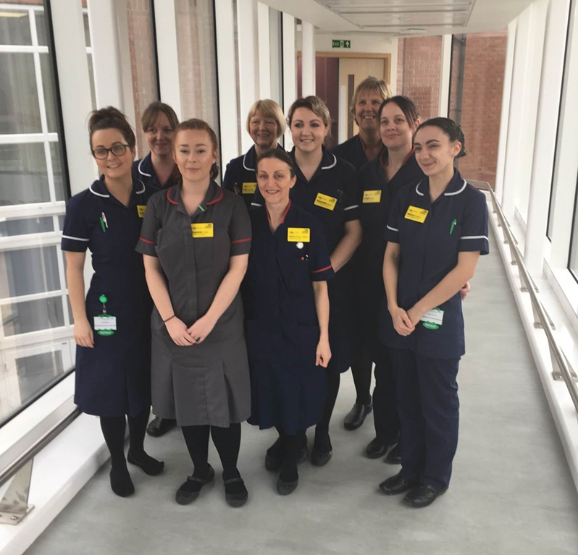
Lead Clinical Nurse Specialists
- Sharon Thorpe-Roberts
- Leigh Evans
- Lynne Sargeant

Clinical Navigator
- Leanne Carter

Clinical Nurse Specialists
- Lucy Moore
- Amanda Daniel
- Pat Crowder
- Jane Temlett
- Nancy Poulton

Cancer of Unknown Primary (CUP)

In-patient and out-patient service that provides support from the CNS and consultant for patients who have been identified as having a cancer with an unknown primary. These professionals will ensure the appropriate investigations are carried out in a timely manner to help identify a patient’s primary to be able to offer the most effective treatment.
There are links to the CUP foundation and the Trust MUO policy on the main page.

Acute Oncology Service (AOS)

Nurse lead service that ensures patients receiving Systemic anti- cancer treatments are properly assessed and the appropriate management plan is followed when admitted to hospital with a cancer or cancer treatment related issue.

They assess and review all patients admitted who fall in categories I – III (see below)

Type I: New Cancers (previously unknown malignancy), presenting with;

- Pleural effusion
- Pericardial effusion
- Lymphangitis Carcinomatosa
- Superior mediastinal obstruction syndrome, including SVC obstruction
- Abdominal Ascites
- Hypercalcaemia
- Spinal cord compression including MSCC
- Cerebral space occupying lesion
- Any other cases where the A&E staff or acute medical team decide an urgent oncology assessment is needed

Type II: Chemotherapy related complications, presenting with;

- Neutropenic sepsis
- Uncontrolled nausea and vomiting
- Extravasation injury
- Acute hypersensitivity reactions including anaphylactic shock
- Complications associated with venous access devices
- Uncontrolled diarrhoea
- Uncontrolled mucositis
- Hypomagnesaemia
- Type II: Radiotherapy related complications, presenting with;
- Acute skin reactions
- Uncontrolled nausea and vomiting
- Uncontrolled diarrhoea
- Uncontrolled mucositis
- Acute radiation pneumonitis
- Acute cerebral/other CNS, oedema

Type III: Known Cancer and complications;

- Lymphangitis Carcinomatosa
- Pleural Effusion
- Pericardial Effusion
- Superior mediastinal obstruction syndrome, including SVC obstruction
- Abdominal Ascites
- Hypercalcaemia
- Spinal cord compression including MSCC
- Cerebral space occupying lesion
- Any other cases where the A&E staff or acute medical team decide an urgent oncology assessment is needed

Specialist Palliative Care

Definitions from NICE 2019
“Specialist palliative care encompasses hospice care (including inpatient hospice, day hospice, and hospice at home) as well as a range of other specialist advice, support and care such as that provided by hospital palliative care teams. Specialist palliative care should be available on the basis of need, not diagnosis.
'People who may benefit from specialist palliative care' are those whose symptoms cannot be managed in a timely way by their usual care team.
The following minimum recommended service levels have been adapted from NICE cancer service guidance and the Department of Health quality markers.
Specialist palliative care inpatient facilities should be responsive to emergency need and able to admit people approaching the end of life at any time of day or night.

Palliative care services should ensure provision to:
- Visit and assess people approaching the end of life face-to-face in any setting between 09.00 and 17.00, 7 days a week (provision for bed-side consultations outside these hours are high-quality care).
- Provide specialist palliative care advice at any time of day or night, which may include telephone advice.
Specialist palliative care, including assessment and advice, may be provided by physicians in palliative medicine or other suitably trained practitioners, such as clinical nurse specialists in palliative care. Qualified district nurses – 'specialist community practitioners in home nursing' – may or may not have an appropriate level of education in specialist palliative care. Social workers, occupational therapists, physiotherapists and other therapists may also have specialist skills in palliative care.”

Local Team
The team at Chesterfield Royal work 7 days a week providing a service to both in and out patients. Patients suitable are those with;
- complex symptom management
- patients with long term conditions and uncertain prognosis

Referrals can be made for many issues such as;
- Symptoms that are difficult to control
- Psychosocial concerns
- Complex needs during treatment
- Non cancer patients with an uncertain prognosis
- Support for carers, families and staff dealing with difficult situations

