

**MURPHY WARD.**

**SURGICAL division.**

**CHESTERFIELD ROYAL HOSPITAL NHS**

**FOUNDATION TRUST.**



**STUDENT LEARNING PACK.**



**INTRODUCTION.**

* This learning package is intended to familiarise you with the procedures, investigations and nursing practices performed on Murphy Ward.
* Your supervisor may wish to discuss some of the content of this package with you.
* THE PACK CONTAINS INFORMATION ABOUT THE FOLLOWING: -
* Welcome to Murphy Ward.
* Available opportunities
* Preoperative care
* Postoperative care
* Common terminology
* Specialised Surgery – urology nursing procedures, TUR syndrome
* Drugs commonly used throughout the ward.
* Learning ideas
* Evaluation
* It will be of benefit to you to read any relevant material and utilise the resources available on Murphy Ward (Resource files, Specialist Nurses, Internet etc.)
* It would also be a good learning experience to track a patient through, beginning in pre-assessment clinic, admission to the ward, to theatre, PACU and finally postoperatively on the ward until discharge home. This enables you to observe the range of care given in particular areas to one particular patient.
* Other interesting aspects of nursing care which you may want to investigate further may include the following: -
* Identify the model of nursing used and how it is implemented.
* Documentation (Admission, transfer, discharge)
* Drug administration
* Meetings (multidisciplinary / student / staff ward meetings)
* Health promotion & teaching sessions – formal & informal
* Role of specific specialist nurses
* Function of Urology, general surgery, orthopaedic, gynae, ENT & Max Fax departments
* Specific clinical procedures (observation & participation of certain procedures) – aseptic preparation, complex wound dressings, stoma care, removal of drains, catheterisation, removal of nasal packs, removal of vaginal packs, splints, casts, slings.

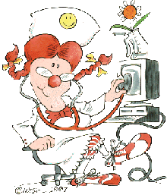

**WELCOME TO MURPHY WARD.**

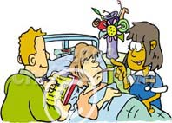

Murphy Ward is a 30-bedded ENT, Maxillo-facial, Ophthalmic, Urology, general surgery, Gynaecology and orthopaedic ward that cares for patients undergoing both elective and emergency surgery. However emergency admissions can be of any surgical speciality.

Within normal clinic working hours, the urology department offers a service for patients with blocked or problem catheters. On occasions, the doctor sees ENT patients on the ward, and therefore this creates a lot of activity but a very challenging learning environment.

In order to effectively care for all patients, the ward is divided each day by patient allocation. The nurses introduce themselves to their patients on admission.

The ward co-ordinator or nurse-in-charge of the shift has primary responsibility for the co-ordination and effective management of the ward.



**OPPORTUNITIES.**



During your placement you should discuss with your mentor / supervisor whether it would be appropriate for you to access the various other learning environments and opportunities related to our ward, these include: -

* Pre-assessment clinic
* Theatre
* PACU
* Urology department
* ENT department
* Max Fax department
* Palliative care team
* Outreach team
* Pain team
* ITU / HDU
* Work with night matron
* X-ray department (various procedures – KUB, IVU, Insertion of nephrostomies etc)
* Speech and Language therapist

Various different clinics take place during the week and therefore discuss with your mentor the best time to visit these areas.

The most appropriate clinics are: -

* ENT Clinic – Mon am - AC/ KIM (alternate).

Wed am - Neck lump clinic.

Final Wed pm in each month – ENT oncology clinic.

Thurs am – MAH.

Fri am -AC/ KIM. Fri all day – Nurse led treatments.

* + Urology Clinic – Mon am – Flexi, Pm – Flow rate.

1st Mon of month NRB – lithotripsy all day.

Tues am – Haematuria/flexi/US, Pm – Flexi.

Wed am – Flexi, Pm – Truss Bx.

Thurs – Flexi all day.

Fri am – Instillation (MMC, BCG etc),

Pm – Vasectomy/ Difficult catheters (Alternate weeks).

Fridays - Nicky James – One-stop Suspected prostate

cancer clinic.

* Max Fax Clinic – Please liase with your mentor or LEM for clinic days.
* Pre-Assessment Clinic – PLEASE CONTACT Annette Booker either 0900 or 1230, on ext. 3244.

However, if your pathway is allocated during this placement, it would be advisable to spend your remaining time on the ward to obtain the full value of this placement.

After discussion with your mentor, please make a note of the aspects of care on Barnes ward that you would like to be involved in………

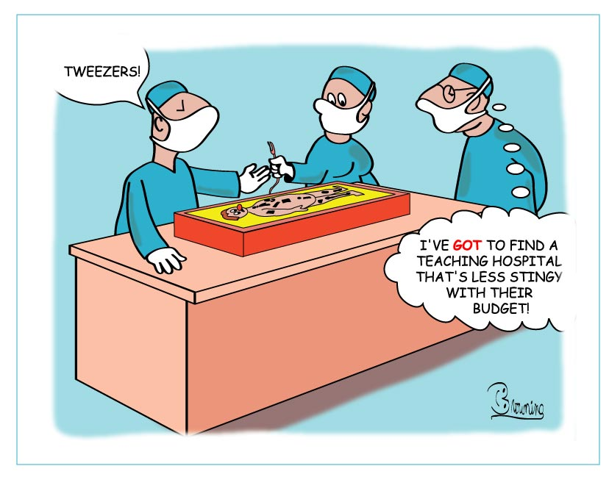

**PRE-OPERATIVE NURSING CARE.**

* What are the legal requirements of informed consent?
* Who can give informed consent?

**Activity.**

# Complete a pre-op checklist and consider its importance.

**Activity.**

Try to find out about current hospital policies for MRSA, ESBL and Clostridium Difficile and how these affect nursing practice and theatre arrangements.

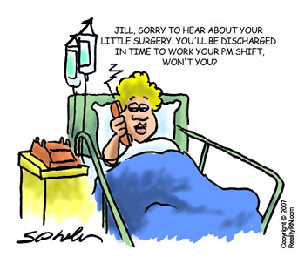

**POST-OPERATIVE NURSING CARE.**

Immediately following theatre, patients will go to PACU where their condition is monitored and stabilised prior to return to the ward. On return, it is highly important that regular observations are performed to detect any complications at an early stage.

**Activity.**

* Find out about post-op observation monitoring, how frequently and consider why.
* What post-op complications might you be monitoring for and how would they present?
* What happens to observations when shock presents?
* What is the Early Warning Score? (NEWS) How and when is it used?
* How would you escalate any concerns?

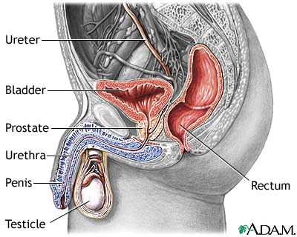

**Urology Terminology.**

|  |  |
| --- | --- |
| CBD | Continuous Bladder Drainage |
| TURP | Trans Urethral Resection of Prostate |
| TURT | Trans Urethral Resection of Tumour |
| BNI | Bladder Neck Incision |
| Cystectomy | Removal of the bladder |
| Cystoscopy | Examination of the bladder using a telescopic instrument |
| Flexible Cystoscopy | As above using a flexible telescope |
| Nephrectomy | Removal of the kidney |
| Nephrostomy | Drain inserted through the skin into the kidney |
| ISC | Intermittent Self Catheterisation |
| ISD | Intermittent Self Dilatation |
| Optical Urethrotomy | Excision of urethral stricture/ narrowing |
| PUJ | Pelvic-ureteric junction |
| PCNL | Percutaneous Nephrolithotomy (Lithotomy- incision into kidney for removal of stones) |
| MSU | Mid Stream Urine |
| CSU | Catheter Specimen of Urine |
| Circumcision | Resection of the foreskin |
| Micturition (Urination) | Passing urine |
| IVU | Intravenous Urogram |
| KUB | X-ray of Kidney, Ureter & Bladder |
| Litholapaxy | The crushing of calculi in the bladder or kidney and removal of fragments of calculus |
| Lithotripsy | The procedure which uses shock waves to break up stones that form in the kidney or bladder |
| USS | Ultrasound Scan |
| Biopsy | Taking a sample of tissue for analysis |
| UTI | Urinary Tract Infection |
| PSA | Prostate Specific Antigen |
| Cystogram | X-Ray test involving instillation of radio-opaque dye into bladder |
| Hydronephrosis | Swelling and enlargement of the kidney due to urine being unable to leave and the build up of back pressure |
| Orchitis | Inflammation of the testis |
| Paraphimosis | The inability to replace the foreskin in its normal position |
| Phimosis | Inability to retract foreskin |
| Prostatitis | Inflammation of the prostate |
| Pylonephritis | Infection & inflammation of the kidney and the renal pelvis |

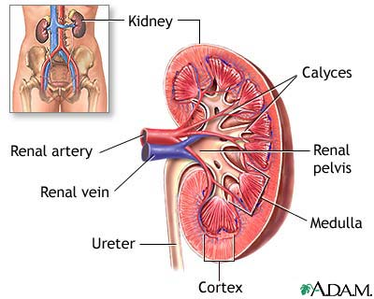

**Routine Urine Testing.**

Usually, on admission, urology patients’ have their urine tested on the ward. This routine ward urine test can detect or rule out primary infection. A sterile urine sample (MSU) or catheter urine sample (CSU) is obtained and tested on our urine analysis machine that provides a digital printout of results.

* Observe and demonstrate the use of the urine analyser and discuss with your mentor its appropriate use and discuss the need to inform doctors of the results.

**Residual Volume Ultrasound Scan.**

This scan is carried out on the ward involving the use of our portable scanner to measure the amount of urine in the bladder using ultrasound waves. It allows staff to recognise if the patient is in retention allowing for appropriate and timely treatment.

No preparation is required prior to the procedure apart from asking the patient to void before the scan is performed.

The head of the scanner is placed on the patients’ lower abdomen in the area of the bladder, using scanning gel to allow conduction of the ultrasound waves. The scanner head is held in position until the residual volume is monitored (few seconds).

* Observe and demonstrate the use of the bladder scanner and discuss with your mentor its appropriate use and the following interventions.

**Catheterisation.**

The indication for catheterisation depends usually on the residual volume of urine. Depending on the reason for catheterisation will depend on the type of catheter used.

* Discuss the reasons for catheterisation and the different types of catheters used. Why and when are 3-way (triple lumen), short term and long-term catheters used? Discuss the catheter size of choice.
* Discuss the difference between acute and chronic retention and try to find out about which medication is frequently given for male retention.
* In chronic retention, find out which blood tests are carried out frequently and why accurate fluid balance monitoring is essential.

**Fluid Balance monitoring.**

One of the most crucial elements of the nurse’s role in the care of particularly urology patients is monitoring fluid intake and output.

On average, patients loose approximately 500mls daily through ‘insensible’ loss, i.e., water lost through the skin, lungs and bowels. The daily urine output demonstrates the volume that the kidneys can ‘handle’. Excessive fluid intake above this volume can result in fluid overload and cardiac failure. Accurate fluid balance recording is, therefore, essential in providing the patient with enough fluids but avoiding fluid overload. There is evidence to suggest that fluid balance recording is not as accurate as it should be.

It is especially important to accurately monitor the fluid balance for patients following urology surgery i.e., TURP/ TURT when bladder irrigation is in situ and to observe for TUR syndrome and act accordingly if any signs and symptoms are present.

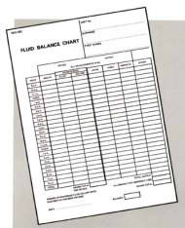

**TUR SYNDROME.**

Patients with liver disease, UTIs, significant muscular atrophy, bladder stones, or obstructive uropathy have a greater risk of developing TUR syndrome, though any patient could experience this complication. TUR Syndrome can occur when patients absorb large volumes (greater than 2 litres) of irrigation fluid free of electrolytes, into the circulation during endoscopic procedures e.g., TURP, TURBT or PCNL. It occurs in approximately 0.5% of TURP’s producing hypervolaemia, and dilutional hyponatraemia, as well as hyperkalaemia that can cause changes in mental status and visual disturbances.

Therefore, it is important that during the procedure, oxygen saturations, electrocardiogram, and serum sodium levels are monitored.

Perioperatively, glycine bladder irrigation is used in cystoscopic resection due to the non-conductive properties when using the diathermy.

As with all surgery involving glycine bladder irrigation, there is a real possibility of the patient experiencing TUR syndrome due to the absorption of the glycine in theatre. (Glycine is one of the 20 amino acids commonly found in proteins).

Biochemical, hypodynamic and neurological disturbances occur.

Dilutional hyponatraemia is the most important – and serious – factor leading to the signs and symptoms. The serum sodium falls for the patient to become unwell.

**Signs & symptoms.**

Symptoms of TUR syndrome includes abdominal pain, arterial hypotension - due to fluid overload, bradycardia, nausea and vomiting, confusion, visual disturbance possibly due to the fact that glycine is a neuro transmitter in the retina, & seizures. If the patient is awake (during spinal anaesthetic) they may report visual disturbances, flashing lights.

The nurse needs to be visulant for TUR syndrome – observing for a rise in blood pressure and for reduced urinary output; on occasions, the patient will complain of flashing lights in their eyes or even blindness. It is treated by monitoring serum, urea and electrolytes (usually sodium will fall) and the administration of IV saline 0.9%. Natural reaction for the inexperienced would be to give IV frusemide because it appears that the patient is overloaded. Discussion surrounds the value of this however, most experienced staff decide not to give frusemide, because it appears to worsen the effects, and the lower the serum sodium even further.

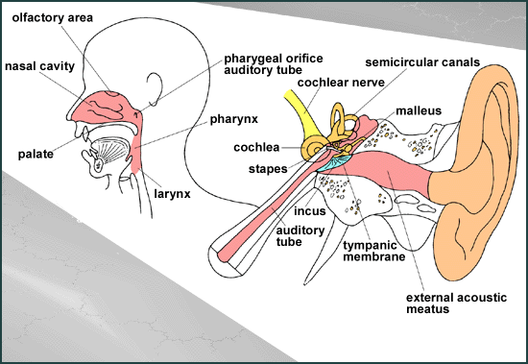

## **ENT/ MAXFAX Terminology**

|  |  |
| --- | --- |
| BAWO | Bilateral Antral Washout |
| BINA | Bilateral Intranasal Antrostomy |
| SMD | Sub Mucous Diathermy |
| EUA | Examination Under Anaesthetic |
| Epistaxis | Nosebleed |
| Pharyngeal Pouch | Dilation of the lower part of the pharynx causing a pouch effect where food and liquid can settle |
| Nasal Polypectomy | Removal of nasal polyps |
| Laryngectomy | Surgical removal of the Larynx, i.e., voice box. |
| Labyrinthitis | Inflammation and infection of the labyrinth, causing Vertigo. |
| Mastoidectomy | Surgical removal of disease from the mastoid, i.e., the bony prominence behind the ear; and the middle ear. |
| Myringotomy | Incision of the tympanic membrane to drain fluid from an infected middle ear. |
| Otitis Externa | Infection of the ear canal leading from the pinna to the tympanic membrane (eardrum). |
| Otitis Media | Middle ear infection. |
| Parotidectomy | Complete or partial removal of the Parotid gland. |
| Rhinoplasty | Straightening of the bridge of the nose. |
| Quinsy/ Peritonsillar Abscess | A complication of tonsillitis. Infection into the tissue around the tonsil |
| Septoplasty | Surgery to correct a septal deviation & allow patient to breath more easily. |
| Septorhinoplasty | Surgery to improve the cosmetic appearance of the nose plus repositioning of the nasal septum to improve breathing. |
| Stridor | Noisy, high-pitched breathing sound where there is restricted airflow/ partial obstruction of the upper respiratory tract, i.e., the larynx. |
| Tinnitus | Noises in the head or ears usually associated with hearing impairment. |
| Tracheostomy | Creation of a breathing hole in the trachea. |
| Laryngoscopy | Examination of the larynx to investigate e.g., hoarseness. Either fibre-optic, Indirect or Direct laryngoscopy |
| Oesophagoscopy | Examination of the oesophagus using either flexible or rigid endoscope. The ‘Oesophagoscopy Protocol’ is followed post-.  operatively |
| Pharyngoscopy | Examination of the upper part of the throat. |
| Laryngitis | Inflammation of the larynx. |
| Myringoplasty | Repair of perforated tympanic membrane. |
| Otalgia | Earache. |
| Vertigo | Abnormal sensation of movement, usually rotationary. May be due to i.e., labyrinthitis, surgery. |
| ORIF | Open-Reduction Internal Fixation. |
| TMJ | Temporomandibular Joint |
| Maxillary Osteotomy | The osteotomy is a complex surgery to reduce the jaw size if it is disproportionate. Mostly after the surgery, braces are required to correct minor movements of teeth. |

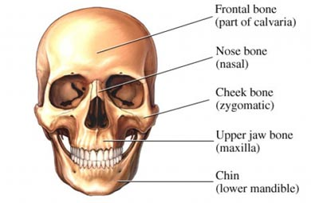

**Gynaecological Investigations and Surgery**

*Laparoscopy*

A procedure used to examine the abdomen to investigate pelvic pain, ectopic pregnancy and infertility.

*Hysteroscopy*

A procedure used to examine the uterus to investigate heavy or irregular menstrual bleeding. A fiber-optic telescope is passed along the vagina through the cervix in order to examine the lining of the uterus. No incision is made.

*Hysterectomy*

Hysterectomy is used to treat tumours, vaginal prolapse, menstrual problems and chronic pelvic pain caused by endometriosis and PID (pelvic inflammatory disease) A total hysterectomy involves removal of the uterus and cervix and can be abdominal or vaginal or laparoscopic.

*Salpingectomy*

It involves partial or total removal of a fallopian tube usually to treat ectopic pregnancy or previous PID infections.

*Oophorectomy*

It involves removal of an ovary.

Many patients having a total hysterectomy also have bilateral salpingoophrectomy at the same time. This is to prevent the risk of ovarian cancer in the future and the formation of scar tissue which may cause long term pain.

***ACTIVITY***

*Find out about post operative gynaecological procedures.*

*Find out about TWOC management after surgery.*

*Care of patient during/after removal of vaginal pack*

|  |  |
| --- | --- |
| TAH | Total Abdominal Hysterectomy |
| TVH | Total Vaginal Hysterectomy |
| TVT | Trans vaginal tapes |
| BSO | Bilateral Salpingoophrectomy |
| USS | Ultrasound scan |
| STOP | Surgical termination of pregnancy |
| HRT | Hormone replacement therapy |
| ERPC | Evacuation of retained products |
| PCOS | Polycystic Ovary syndrome |
| D C | Dilatation and Curettage |

**Medications generally used on Murphy ward.**



|  |  |  |  |  |
| --- | --- | --- | --- | --- |
| DRUG | DOSE | ROUTES | INDICATIONS | SIDE EFFECTS |
| Trimethoprim |  |  |  |  |
| Oxybutynin |  |  |  |  |
| Ciprofloxacin |  |  |  |  |
| Diclofenac |  |  |  |  |
| Act rapid |  |  |  |  |
| Doxazosin |  |  |  |  |
| Domperidone |  |  |  |  |
| Codeine phosphate |  |  |  |  |
| Metronidazole |  |  |  |  |
| Cyclizine |  |  |  |  |
| Buscopan |  |  |  |  |
| Naseptin |  |  |  |  |

Please try to find out: - the Indication, possible side effects, what type of medication is it, i.e., antibiotic etc, contra-indications, maximum dosage, route and any other name by which the drug is known. Have a go at filling in this table.

**Please familiarise yourself with the following conditions:**

1. Deep vein thrombosis (DVT) ............................................................................................................................ ............................................................................................................................ ............................................................................................................................

2.Priapism

............................................................................................................................ ............................................................................................................................ ............................................................................................................................

3. Prostatitis

............................................................................................................................ ............................................................................................................................ ............................................................................................................................

4. Pyelonephritis

............................................................................................................................ ............................................................................................................................ ............................................................................................................................

5. Benign prostatic hyperplasia

............................................................................................................................ ............................................................................................................................

**Year one Learning Ideas**

Aim to have 1-2 patients allocated to you at the commencement of each shift (considering learning needs for the patient you choose).

* Understanding the basics of Activities of daily Living
* Communication
* Spend the first week learning from the Healthcare assistants (longer if required)
* Moving and handling (using hoist, rotunda, arjo etc)
* Documentation and rounding charts.
* Vital signs recording
* Assisting with washing and dressing
* Look after patients with stomas, catheters and nephrostomies.
* Completing pre op checklists under supervision

**Year Two Learning ideas:**

Each shift, have a consistent caseload of 2-4 patients, support and be involved in the learning and development of year one students.

* Consider the differences between emergency & elective admissions:
* Complete admission booklets considering all aspects of Harm Free Care, risk assessments, care planning: consider all aspects of the nursing process.
* Provide catheter and nephrostomy care inc Houdini paperwork.
* Look after patients with drains- under supervision can remove drains and sutures.
* Provide wound care- aseptic technique and changing dressings as per TVN plan or wound chart.
* Observe blood transfusions inc the 2 nurse checks procedure and how to take blood observations - observing for signs of a transfusion reaction. Being aware of the massive haemorrhage protocol.
* Undertaking neuro observations and AVPU

**Year Three Learning Journey ideas**

Each shift has a consistent caseload of a bay, overseeing second- and first-year students if appropriate ensuring you’re the running of the bay is completed.

Medication Management: Be fully involved in all aspects, as appropriate, for your patients Spend some time with ward pharmacist: learning outcomes to consider: NBM policy & medications. Ordering, receiving, storing medications including controlled drugs, stock items, patients regular medications, emergency drug cupboard items, PGDs, self-medicating policy, escalation policies/actions to take with medication errors/reactions. REMEMBER, that you will soon be qualified & the above will be your responsibility; take this opportunity to learn about the above & learn to complete the above in this learning period.

* Practice correct ANTT technique
* Spend time with discharge coordinator (have goals)
* Observe a clinical incident form being completed online/participate in completing this if appropriate.
* Fully immerse self in delivering handovers, safety huddle, MDT (daily & full), take part in ward rounds, telephone, SBARs and post op care.
* Become familiar with using open ward updating, discharge dates, transferring patients.
* Become familiar with utilising the BNF and Medussa.
* Become familiar with medical devices in regard to medicine administration: Consider care of substance misuse in patients: & policy/policies in regards to this i.e. assessment/methadone prescription; & the needs of these individuals in regards to analgesia.
* Consider spending time with the pain team.
* Consider spending time with the alcohol nurse: consider aspects such as referrals, DOLs.
* Liaising with members of the MDT and making appropriate referrals to other services.

**Admission Procedure Brief Guidance**

* Introduce yourself to patient and ask what the patient likes to be called and write their name on the whiteboard behind the bed.

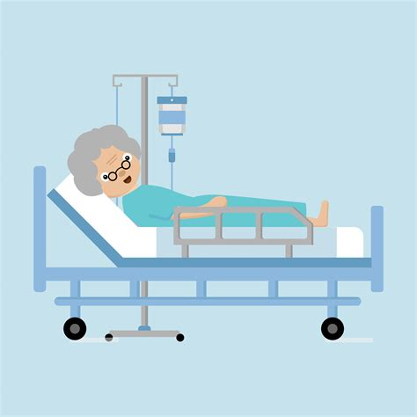

* Identify any magnets (falls risk, NBM, Clear fluids, impaired vision etc.) that need to be placed on their board.
* Record and report observations of vital signs and assess mood/level of consciousness – inform nurse on duty of any abnormalities using the NEWS scoring system on vitals.
* Explain call system and orientate to ward environment.
* Complete initial nursing assessment and complete admission booklet and care plan.
* Apply white wristband for pt. identification.
* Ensure patients do not have any broken skin or pressure sores by conducting a skin inspection and maintain clear records as appropriate.
* Ascertain if patient has valuables that require depositing in a locked cupboard if no family available to take home. Ask patient to sign indemnity if able and ensure safe record is maintained in patient notes. Complete a property list if patient unable to look after their own belongings.
* Ensure all patients have their risks assessments completed within 4 hours of arrival to the ward (MUST, Purpose T, fall, MRSA Screening etc.).
* Briefly explain to patient and relatives the ward routine/visiting, nursing organisation.
* Check whether patient has brought his own medication and document on nursing records and store in patient’s bedside locker and inform the nursing staff.

**USEFUL INFORMATION.**

**Specialities & Consultants.**

***Urology.***

#### Mr Shipstone (DS1)

#### Mr Iderapalli (KMRI)

* Mr Riaz (AAR)
* Mr Majumdar (PPM)
* Mr Vaswani (NN)

***Ear, Nose & Throat (ENT)***

* Mr Chidambaram (AC)
* Miss Midwinter (KIM)
* Mr Orilarinde (OO)
* Miss DeCasso (MD1)

##### *MaxFax*

* Mr Doyle (PTD)
* Mr Orr (RLO)

**Orthopaedic**

* Mr Garcia (JAG)
* Mr Sinha (APS)
* Mr Wright (JDW)
* Mr Holloway (ESH)
* Mr Morris (MWM)

***General Surgery***

* Mr Everitt (NJE)
* Mr Ravi (KR)
* Mr Neurula
* Mr Gupta (RG)
* Mr Bagnall (MB)
* Mr Schuijtvlot (NMS)
* Mr Ardley (RRA)
* Mr Mancas (MOM)
* Mr Sargen
* Miss Rosser
* Mr Armarnath

***Gynaecology***

* Mr Smith (SCS)
* Mr Thambirajah (GRT)
* Mr Kumar(KM)
* Miss Cresswell (JLC)
* Miss Matthew (DM)
* Miss Parratt (JRP)

**Emergency telephone numbers.**

**Cardiac Arrest: 2222**

**Fire: 2000**

**Security: 7777**

**CONGRATULATIONS!!**

We hope that you have enjoyed your placement on Murphy ward and that you may want to come back to us in the future.

You can use this space below to list any questions you may like to ask your supervisor as you work through the learning booklet.

**EVALUATION.**



In order for us to continue to provide a valuable learning environment and experience for our students, we would appreciate it if you could spare a few minutes to complete the evaluation and let us know what you have enjoyed and give us any ideas on how we can improve things in the future.

* What have you enjoyed the most?
* Is there any part that you didn’t enjoy?
* How did you find the information etc. within the learning package? How could it be improved?
* Did you find the ward staff helpful and gave you up-to-date information?
* If you were able to visit any of the clinics, which one did you enjoy the most and why? Would you recommend it to future students?
* Overall, how do you think we could have improved your experience on Murphy ward?

*Thank-you and good luck in the rest of you training.*

*If we can be of any help in the future, don’t hesitate to contact one of the staff.*

*All the staff on Murphy Ward*