NGS MACMILLAN UNIT CHEMOTHERAPY TEAM

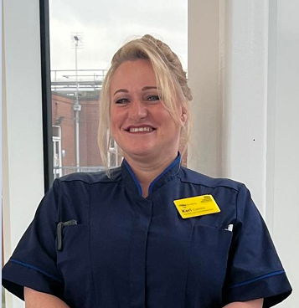
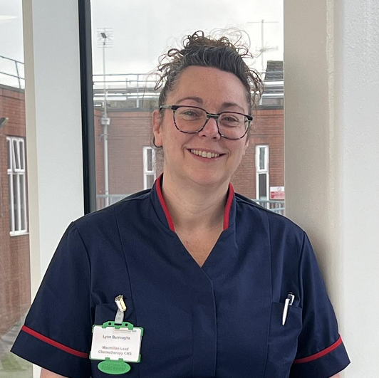

KERI COMINS LYNN BURROUGHS
MACMILLAN LEAD MACMILLAN LEAD CHEMOTHERAPY
CHEMOTHERAPY NURSE CLINICAL NURSE SPECIALIST
Keri currently supports and advises staff and teams working in Chemotherapy Services within NGS Macmillan Unit that are responsible for giving your care. Keri also supports our chemotherapy educator.
Lynn is responsible for day-to-day operational running of the main Chemotherapy Treatment Area and its nursing team giving your care.

As Macmillan Lead Chemotherapy Nurse and Macmillan Lead Chemotherapy CNS we are here to support our patients, carers, visitors, and nursing teams to deliver outpatient chemotherapy and immunotherapy to oncology, palliative and haematology outpatients living with cancer. These interventions allow our patients to live a good quality of life as an outpatient, with access to many different services that enable their cancer journey to be as positive as possible.

If there is anything you would like to highlight or talk to us about you are welcome to make contact and we can arrange a suitable time to meet and discuss

Tel No. 01246 277271 Ext 6495/6493

